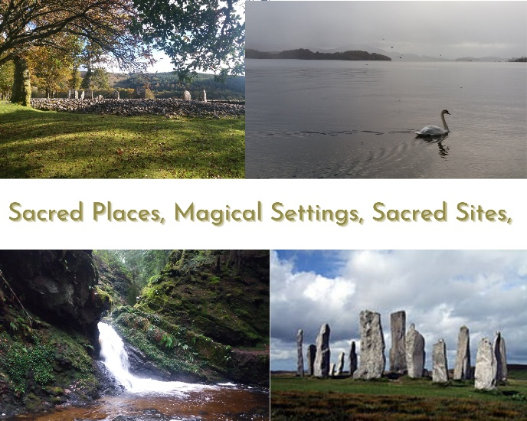

Dowsing Testimonials
Review One
Margery is a wonderful guide and teacher. From the moment you arrive, you feel held in a calm, supportive space where nothing is rushed and no question is ever too much trouble. She listens deeply, responds with kindness, and explains dowsing in a way that feels clear, accessible, and confidence-building.
Her instruction is gentle but precise, allowing you to learn at your own pace while feeling quietly encouraged throughout. There’s a real sense of trust in her presence. You always feel you’re in very good hands. I left the workshop feeling grounded, uplifted, and genuinely grateful for the care and attention Margery brings to her work.
I would wholeheartedly recommend her workshops to anyone, whether you’re completely new to dowsing or looking to deepen your practice. Lea Taylor

Review Two
I received a powerful healing and dowsing for health from Margery. I was absolutely amazed at the accuracy as every single thing Margery said was spot on. When I received the healing session, I immediately felt lighter, like a huge weight had been lifted from my shoulders. Margery is extremely talented and I was so grateful for her help and guidance. Gilly

Review Three
Thank you for the dowsing session on Friday. This is day 5 and Friday was my first experience of dowsing - it was amazing! I’ve been struggling with ‘stuckness’ and just didn’t know why or how to get out of this situation. I’ve also had a very sore back. Margery asked questions then did the dowsing with a little bobber. It didn’t really feel like anything but oh my goodness the next day was a whole new start. My back is no longer sore, the tension has gone and although I still have decisions to make, I can see choices which I couldn’t see before, or even imagine. I feel lighter.
Definitely give this a try. Thank you, Margery, you are a star. Laura.

Review Four
Had my 1st ever dowsing session with Margery tonight. I have had quite a few health issues lately and have been attending the doctor for these. During my dowsing session Margery picked up on my issues plus a few more. What I liked about the session was that it has a holistic approach and looks at your mind, body and soul. Not just focusing on the illness, it goes deeper into the cause of the unbalance. In my life I have tried various alternative therapies but have to say the dowsing session was one of the most beneficial all-round treatments I have had. Nicola.

Review Five
Feedback is you were scarily spot on with everything to be honest 👌🤣 I didn't expect it to be specific and in depth as it was! You've given me loads to work with and I can't wait to make some changes and see what I've improved over the next 6 months or so! Kirsty

Review Six
When Margery and I bumped into each other as strangers we quickly felt like we’d known each other somehow before and couldn’t explain it. It was odd.
She happened to be in the place where my new business venture was just beginning, and she picked up on the history and unsettled feeling of the building as it’s very old and parts of it had been left unused for a long time.
After showing her round I knew right away the universe had somehow meant us to meet.
She suggested gently that the space might need a bit of spiritual cleansing, and would I like her to come back. I had felt it too, though I couldn’t quite put my finger on it and would never have thought to bring someone in.
Margery so kindly gave of her time, was deeply caring, and incredibly knowledgeable. She brought a peaceful energy with her, and ever since the house has felt warmer, lighter and full of love. And just when I thought the magic had settled, a massive toad appeared at my front door—as if to say thank you! A wonderful person with a real understanding of things both seen and unseen. I’m so glad we met that day. Gayanne

