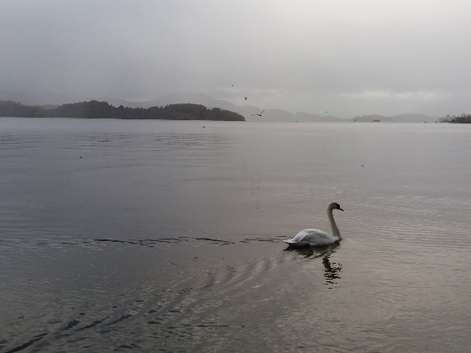
Funeral Testimonials

Margery officiated my Uncle’s funeral and she made it so personal. Sometimes funerals are about the person but spoken by someone who did not know them and it’s often obvious. Margery not only understood the sadness the family & friends felt but also took the time to speak to family beforehand and enlightened us to who he was and brought joy and laughter to a sad day. She has a kindness and empathy that helps those who are in despair smile and feel better, if only for a brief moment. Margery Bambrick is a beautiful soul xx Lisa S, Edinburgh

Margery is so compassionate and makes the whole service about the person and her support of the family is amazing. At Weddings she is so bubbly and happy makes it an amazing service and a great start to any day. One very amazing person and would highly recommend for any occasion. Val H, Edinburgh

I've attended a couple of funerals done by Margery Bambrick. She brings a personal touch with both empathy, humour and understanding of the families wishes, you leave the service knowing the life of the deceased in a more intimate way, if you want warmth and love this is the lady you need. Tricia W, Edinburgh

Margery Bambrick is amazing, the empathy and kindness she has for both families and friends. Margery conducted both funerals for my husband and my mum, the personal touch with love and compassion made the day a bit easier, (even just for a wee while) I couldn’t recommend this beautiful loving amazing lady enough. Gale M, Edinburgh

I have attend funerals that Margery Bambrick has taken which was why she was 1st choice for a family relative. A very kind lovable lady with a big heart. Goes out her way to make you feel comfortable. Very professional at what she does. Gina M, Fife

