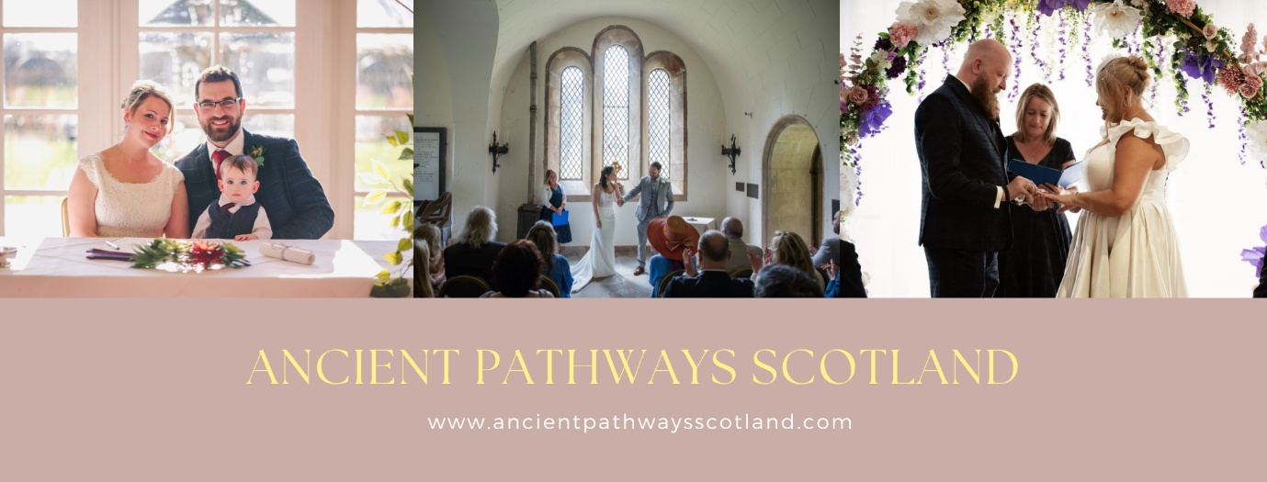

Testimonials
From destination weddings I have officiated from places couples as far as Australia, Norway, America and Germany and from Loch Lomond to Dumfries there have been so many memorable ceremonies to date with some testimonials added here below.

Fee’s depend on travel from East Lothian, any possible overnight stay if I am more than three/four hours from home and possible rehearsals and range from £450.00 - £525.00 for weddings, including in person meetings & £450.00 for handfasting’s and elopement ceremonies with no in person meeting until the day with all contact via Zoom.

Should you wish to discuss any further details please feel free to get in touch on the contact page.
I look forward to hearing back from you.

Reviews
Margery Bambrick is amazing at doing any of the things you need. At Funerals she is so compassionate and makes the whole service about the person and her support of the family is amazing. At Weddings she is so bubbly and happy making it an amazing ceremony and a great start to any day. One very amazing person and would highly recommend for any occasion. Val Hunter

My wife and I are so thankful that we were put in touch with Margery to conduct our wedding ceremony in North Berwick. Our wedding planning was not easy due to us living in Germany and having suffered a loss in the family shortly before the big day, but Margery was very helpful and supportive and really took the time to plan a beautiful ceremony with us. The reading fitted us perfectly and blended in a few Scottish traditions that went down especially well with our German guests. All the guests we spoke to loved the personal touch of the reading and how Margery brought the two families together and even involved the parents in the ceremony. It was an altogether unforgettable and perfect start to our big day. Thank you, Margery. Bobby & Tanya

Margery was the celebrant at our wedding. She was a delight to work with, keeping us on track until the wedding and excelling in carrying out our ceremony. Margery brought so much laughter and light hearted-ness to our wedding as well as a few tears from our guests. Our ceremony was so personalised that our guests were questioning if we wrote it! All credit has to go to Margery who from a few sentences put together the most perfect ceremony for us, highlighting in our vows what wanted from marriage and from our life together. She’s very friendly, professional and we couldn’t asked for a better start in our married life. The perfect ceremony from an absolute wizard of a celebrant! Thanks Margery. You gave us memories that we will cherish forever! Katy & Ollie

We can’t thank you enough for your efforts on Sunday, and for your preparation leading up to it. We both feel that something changed in our relationship on Sunday, which surprises us as we didn’t think that our love could deepen. However, your merging of the clans, the inclusion of my nephews in the ceremony, your re-phrasing of the information we provided in our questionnaires, and your “surprise” vows have made us realize how much we want to spend the rest of our lives together, and how much we are looking forward to doing so. Our guests raved about the ceremony, both during the dinner and dance, and at the post-wedding bash. You will always have a place in our hearts. Bill and Kartar

Daniel & Kirsty – Baby Blessing & Surprise Wedding
We are so happy we chose Margery to be the celebrant at our son’s welcoming ceremony and our surprise wedding. Without actually meeting us in person until the day, through emails and Skype chats, Margery was able to create and deliver a beautiful and unique script for both Jack’s welcoming and our wedding. The ceremonies were definitely the highlight of the day for everyone. We all laughed, cried, shared stories of Jack’s coming into the world and us as a couple. She really made our ceremonies so personal, relaxed, heartfelt and fun-filled, exactly as we wanted. She had lots of ideas for how to do this, including naming pebbles for Jack so he will forever have a keepsake of those who attended his welcoming and have promised to help guide and support him through life and a quaich cup for both our fathers to symbolise the joining of our Scottish and English families. All her little personal touches made it so special even down to revealing the big surprise at the end of Jack’s ceremony that we were also going to have a wedding. We couldn’t recommend Margery highly enough, she is amazing at what she does.

